
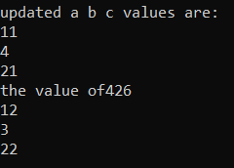
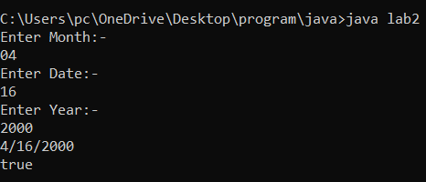
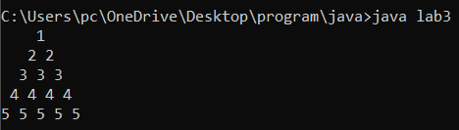
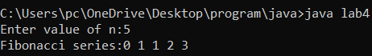
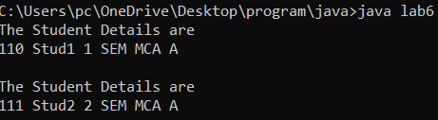
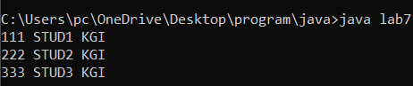
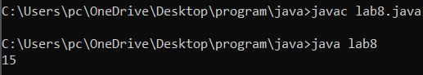
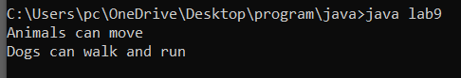
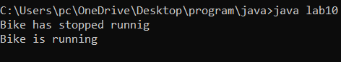
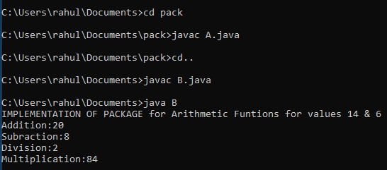
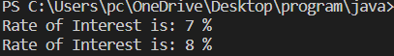
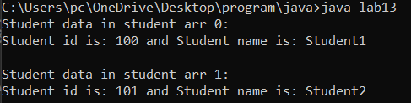
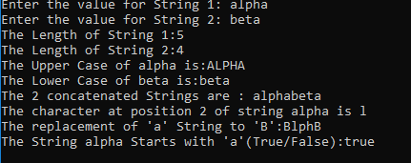
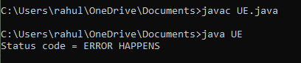
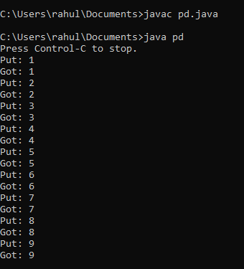
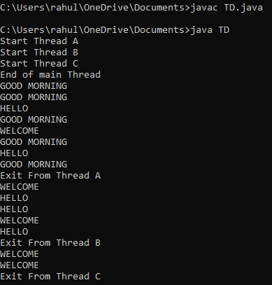
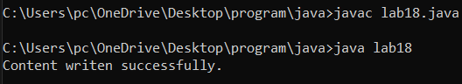
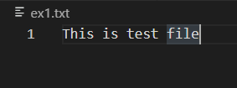
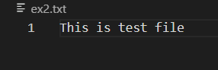
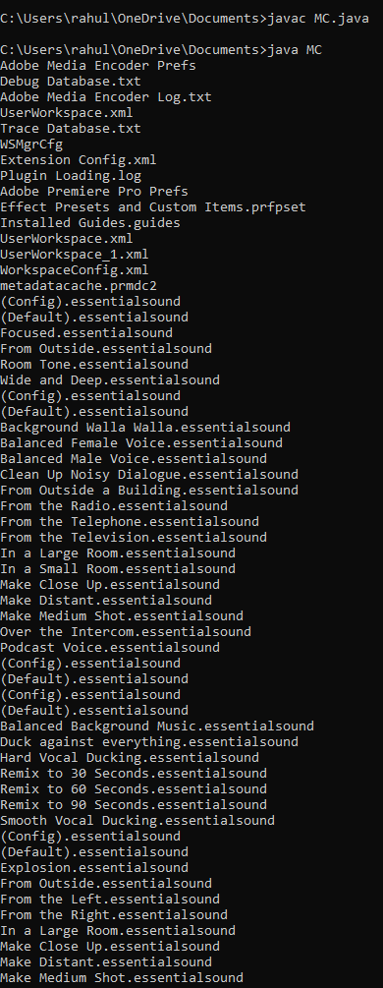
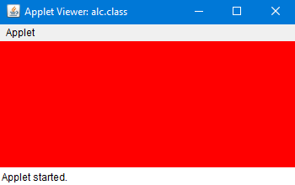
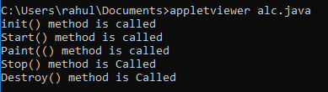
Lab Record on

Object Oriented Programming with JAVA Lab

Submitted in partial fulfillment of the requirements for the
Object Oriented Programming with JAVA LAB in

I Semester

MASTER OF COMPUTER APPLICATIONS

Bangalore North University

Submitted by
(STUDENT NAME)
(REGISTER NO)

Lab Guide
Dr. Bobby Lukose

Department of MCA
Krupanidhi Group of Institutions
Affiliated To Bangalore North University
ChikkaBellandur, Carmelaram Post, VarthurHobli
Bangalore-560035

Krupanidhi Group of Institutions

certificate

This is to certify that the report entitled “Object Oriented Programming with JAVA LAB “ embodies the original work by STUDENT NAME (RESISTER NO) in the partial fulfilment of the requirements for Object Oriented Programming with JAVA LAB for MCA, I Semester course during the academic semester from March 2021 to June 2021 as prescribed by Bangalore North University.

Lab Guide Head of the Department

Dr. Bobby Lukose

Place:
Date:
Krupanidhi Group of Institutions

certificate

This is to certify that the report entitled “Object Oriented Programming with JAVA LAB” embodies the original work by STUDENT NAME (REGISTER NO) in the partial fulfilment of the requirements for Object Oriented Programming with JAVA LAB for MCA, I Semester course during the academic semester from March 2021 to June 2021 as prescribed by Bangalore North University.

External Examiner

1._____________________

2._____________________

Place:
Date:

Table of Contents

S.No | Date | Program Title | Page No
1 | 04-01-2022 | Develop a JAVA program to demonstrate the precedence and associativity among arithmetic operators. The program should also demonstrate how the default precedence can be overridden. | 6
2 | 08-01-2022 | Write a JAVA program to validate a date. The program should accept day, month and year and it should report whether they form a valid date or not. | 7
3 | 11-01-2022 | Write a JAVA program to display the following pattern.  1  2 2  3 3 3  4 4 4 4  5 5 5 5 5 | 8
4 | 13-01-2022 | Write a JAVA program to print the first n members of Fibonacci series. | 9
5 | 18-01-2022 | Write a program to generate the multiplication tables of a range of numbers between m and n inclusive and m < n. | 10
6 | 20-01-2022 | Write a JAVA program to define a class, define instance methods for setting and retrieving values of instance variables and instantiate its object | 11
7 | 22-01-2022 | Write a JAVA program to demonstrate static member data and static member methods | 12
8 | 25-01-2022 | Write a JAVA Program to demonstrate nested classes | 13
9 | 27-01-2022 | Write a JAVA program to demonstrate dynamic method dispatch. | 14
10 | 01-02-2022 | Write a JAVA program to implement inheritance and demonstrate use of method overriding. | 15
11 | 03-03-2022 | Write a JAVA program to implement the concept of importing classes from user defined package and creating packages. | 16
12 | 19-03-2022 | Write a program to demonstrate abstract class and abstract methods | 17
13 | 24-03-2022 | Write a JAVA Program to implement an array of objects of a class. | 18
14 | 04-05-2022 | Write a JAVA program to demonstrate String class and its methods. | 19
15 | 07-05-2022 | Write a JAVA program to implement the concept of exception handling by creating user defined exceptions. | 20
16 | 13-05-2022 | Write a JAVA program using synchronized threads, which demonstrates producer consumer concept. | 21
17 | 14-05-2022 | Write a JAVA program that creates three threads. First thread displays “Good Morning” every one second, second thread displays “Hello” every two seconds and the third thread displays “Welcome” every three seconds. | 24
18 | 21-05-2022 | Write a JAVA program which uses FileInputStream / FileOutPutStream Classes. | 26
19 | 25-05-2022 | Write a JAVA program to list all the files in a directory including the files present in all its subdirectories. | 27
20 | 27-05-2022 | Write a JAVA program to demonstrate the life cycle of applet | 28

Program No:1
AIM:
Develop a JAVA program to demonstrate the precedence and associativity among arithmetic
operators. The program should also demonstrate how the default precedence can be
overridden.

SOURCE CODE:
public class lab1 {
public static void main(String[] args) {
int a=10,b=5,c=20;
int x =++a - b + c++ + a * b + c * a- --b +c %b*a;
System.out.println("before overriding the operator precedence");
System.out.println(x);
System.out.println("updated a b c values are:");
System.out.println(a);
System.out.println(b);
System.out.println(c);
int y=(++a -b)* c++ + a * b +c * (a- --b) + c % b*a;
System.out.println("the value of"+y);
System.out.println(a);
System.out.println(b);
System.out.println(c);
}
}
OUTPUT:

Program No:2
AIM:
Write a JAVA program to validate a date. The program should accept day, month and year and it should report whether they form a valid date or not.
SOURCE CODE:
import java.util.Scanner;
import java.util.regex.Matcher;
import java.util.regex.Pattern;
public class lab2 {
public static boolean isValidDate(String d)
{
String regex="^(1[0-2]|[1-9])/(3[01]"
+"|[12][0-9]|0[1-9])/[0-9]{4}$";
Pattern pattern = Pattern.compile(regex);
Matcher matcher = pattern.matcher((CharSequence)d);
return matcher.matches();
}
public static void main(String[] args) {
Scanner sc=new Scanner (System.in);
System.out.println("Enter Month:-");
int month=sc.nextInt();
System.out.println("Enter Date:-");
int date=sc.nextInt();
System.out.println("Enter Year:-");
int year=sc.nextInt();
String x=month+"/"+date+"/"+year;
System.out.println(x);
System.out.println(isValidDate(x));
}
}
OUTPUT:
Program No:3
AIM:
Write a JAVA program to display the following pattern.
1
2 2
3 3 3
4 4 4 4
5 5 5 5 5

SOURCE CODE:
public class lab3 {
public static void main(String[] args) {
int i,j,row=5;
for(i=0;i<row;i++)
{
for(j=row-i;j>1;j--)
{
System.out.print(" ");
}
for(j=0;j<=i;j++)
{
System.out.print(i+1+" ");
}
System.out.println();
}
}
}

OUTPUT:

Program No:4
AIM:
Write a JAVA program to print the first n members of Fibonacci series
SOURCE CODE:
import java.util.Scanner;
public class lab4
{
public static void main(String[] args) {
int n,a=0,b=0,c=1;
Scanner s=new Scanner (System.in);
System.out.print("Enter value of n:");
n=s.nextInt();
System.out.print("Fibonacci series:");
for(int i = 1; i <= n; i++)
{
a = b;
b = c;
c = a + b;
System.out.print(a+" ");
}
}
}
OUTPUT:

Program No:5
AIM:
Write a program to generate the multiplication tables of a range of numbers between m and n inclusive and m < n.
SOURCE CODE:
import java.util.Scanner;
public class lab5{
public static void main(String[] args) {
Scanner s=new Scanner(System.in);
System.out.print("Enter the value of m:- ");
int m=s.nextInt();
System.out.print("Enter the value of n:- ");
int n=s.nextInt();
if(m<n)
{
for(int i=1;i<=10;i++)
{
for(int j=m;j<=n;j++)
{
System.out.printf(j+"*"+i+"="+j*i);
}
System.out.println(" ");
}
}
else
{
System.out.print("m should be lesser than n");
}
}
}
OUTPUT:

Program No:6
AIM:
Write a JAVA program to define a class, define instance methods for setting and retrieving
values of instance variables and instantiate its object.
SOURCE CODE:
public class lab6 {
int rollno;
String Name;
String Class;
String Section;
void insertRecord(int R,String N,String C,String S)
{
rollno=R;
Name=N;
Class=C;
Section=S;
}
void display()
{
System.out.println("The Student Details are");
System.out.println(rollno+" "+Name+" "+Class+" "+Section);
System.out.println();
}
public static void main(String[] args) {
lab6 s1=new lab6();
lab6 s2=new lab6();
s1.insertRecord(110,"Stud1","1 SEM MCA","A");
s1.display();
s2.insertRecord(111,"Stud2","2 SEM MCA","A");
s2.display();
}
}
OUTPUT:
Program No:7
AIM:
Write a JAVA program to demonstrate static member data and static member methods
SOURCE CODE:
class Student{
int rollno;
String name;
static String college = "KDC";
static void change(){
college = "KGI";
}
Student(int r, String n){
rollno = r;
name = n;
}
void display(){System.out.println(rollno+" "+name+" "+college);}
}
public class lab7{
public static void main(String args[]){
Student.change();
Student s1 = new Student(111,"STUD1");
Student s2 = new Student(222,"STUD2");
Student s3 = new Student(333,"STUD3");

s1.display();
s2.display();
s3.display();
}
}
OUTPUT:
Program No:8
AIM:
Write a JAVA Program to demonstrate nested classes
SOURCE CODE:
class OuterClass {
int x = 10;
class InnerClass {
int y = 5;
}
}
public class lab8 {
public static void main(String[] args) {
OuterClass myOuter = new OuterClass();
OuterClass.InnerClass myInner = myOuter.new InnerClass();
System.out.println(myInner.y + myOuter.x);
}
}
OUTPUT:
Program No:9
AIM:
Write a JAVA program to demonstrate dynamic method dispatch.
SOURCE CODE:
class Animal {
public void move() {
System.out.println("Animals can move");
}
}

class Dog extends Animal {
public void move() {
System.out.println("Dogs can walk and run");
}
}

public class lab9 {

public static void main(String args[]) {

Animal a = new Animal();
Animal b = new Dog();

a.move();
b.move();
}
}
OUTPUT:

Program No:10
AIM:
Write a JAVA program to implement inheritance and demonstrate use of method overriding.
SOURCE CODE:
class Bike {
public void move() {
System.out.println("Bike has stopped running");
}
}
class univ extends Bike {
public void move() {
System.out.println("Bike is running");
}
}
public class lab10{
public static void main(String args[]) {
Bike a = new Bike();
Bike b = new univ();
a.move();
b.move();
}
}
OUTPUT:

Program No:11
AIM:
Write a JAVA program to implement the concept of importing classes from user defined package and creating packages.
SOURCE CODE:
package pack;
public class A{
public void msg(int X,int Z)
{
int c=X+Z;
int d=X-Z;
int e=X/Z;
int f=X*Z;
System.out.println("IMPLEMENTATION OF PACKAGE for Arithmetic Funtions for values "+X+" & "+Z);
System.out.println("Addition:"+c);
System.out.println("Subraction:"+d);
System.out.println("Division:"+e);
System.out.println("Multiplication:"+f);
}
}
---------------------------------------------------------------------------------------------------------------------
import pack.A;
class B{
public static void main(String args [])
{
int a=14,b=6;
A obj=new A();
obj.msg(a,b);
}
}
OUTPUT:

Program No:12
AIM:
Write a program to demonstrate abstract class and abstract methods.
SOURCE CODE:
import java.io.*;
import java.util.*;
abstract class A {
int a=9,b=10,c;
abstract void mS();

public void B() {
c=a+b;
System.out.println("SUM of "+a+" & "+b+" is: "+c);
}
}

class D extends A {

public void mS() {
c=a-b;
System.out.println("SUBRACTION of "+a+" & "+b+" is: "+c);
}
}

class lab12 {
public static void main(String[] args) {
D d1 = new D();
d1.mS();
d1.B();
}
}
OUTPUT:

Program No:13
AIM:
Write a JAVA Program to implement an array of objects of a class
SOURCE CODE:
class lab13 {
public static void main(String args[])
{
Student[] arr;
arr = new Student[2];
arr[0] = new Student(100, "Student1");
arr[1] = new Student(101, "Student2");
System.out.println("Student data in student arr 0: ");
arr[0].display();
System.out.println( "Student data in student arr 1: ");
arr[1].display();
}
}
class Student {

public int id;
public String name;
Student(int id, String name)
{
this.id = id;
this.name = name;
}
public void display()
{
System.out.println("Student id is: " + id + " "+ "and Student name is: "+ name);
System.out.println();
}
}
OUTPUT:
Program No:14
AIM:
Write a JAVA program to demonstrate String class and its methods.
SOURCE CODE:
import java.io.*;
import java.util.*;
class ary
{
public static void main(String args[])
{
Scanner sc=new Scanner(System.in);
String s1,s2,up,low;
System.out.print("Enter the value for String 1: ");
s1=sc.nextLine();
System.out.print("Enter the value for String 2: ");
s2=sc.nextLine();
up=s1.toUpperCase();
low=s2.toLowerCase();
String rs=s1.replace("a","B");
System.out.println("The Length of String 1:"+s1.length());
System.out.println("The Length of String 2:"+s2.length());
System.out.println("The Upper Case of "+s1+" is:"+up);
System.out.println("The Lower Case of "+s2+" is:"+low);
System.out.println("The 2 concatenated Strings are : "+s1.concat(s2));
System.out.println("The character at position 2 of string "+s1+" is "+s1.charAt(1));
System.out.println("The replacement of 'a' String to 'B':"+rs);
System.out.println("The String "+s1+" Starts with 'a'(True/False):"+s1.startsWith("a"));
}
}
OUTPUT:

Program No:15
AIM:
Write a JAVA program to implement the concept of exception handling by creating user defined exceptions.
SOURCE CODE:
class UE{
public static void main(String args[]){
try{
throw new UserException("ERROR HAPPENS");
}
catch(UserException e){
System.out.println(e) ;
}
}
}
class UserException extends Exception{
String s1;
UserException(String s2) {
s1=s2;
}
public String toString(){
return ("Status code = "+s1) ;
}
}

OUTPUT:

Program No:16
AIM:
Write a JAVA program using synchronized threads, which demonstrates producer consumer concept.
SOURCE CODE:
class Q
{
int n;
boolean valueSet = false;
synchronized int get()
{
while(!valueSet)
try {
wait();
}
catch(InterruptedException e)
{
System.out.println("InterruptedException caught");
}
System.out.println("Got: " + n);
valueSet = false;
notify();
return n;
}
synchronized void put(int n)
{
while(valueSet)
try
{
wait();
}
catch (InterruptedException e)
{
System.out.println("InterruptedException caught");
}
this.n = n;
valueSet = true;
System.out.println("Put: " + n);
notify();
}
}
class Producer implements Runnable
{
Q q;
Producer (Q q)
{
this.q = q;
new Thread(this, "Producer").start();
}
public void run ()
{
int i = 1;
while(i<10)
{
q.put(i++);
}
}
}
class Consumer implements Runnable
{
Q q;
Consumer(Q q)
{
this.q = q;
new Thread(this, "Consumer").start();
}
public void run()
{
int j = 1;
while(j<10)
{
q.get();
}
}
}
class pd
{
public static void main(String args[])

{

System.out.println("Press Control-C to stop.");

Q q = new Q();
new Producer(q);
new Consumer(q);
}
}

OUTPUT:

Program No:17
AIM:
Write a JAVA program that creates three threads. First thread displays “Good Morning” every one second, second thread displays “Hello” every two seconds and the third thread displays “Welcome” every three seconds.
SOURCE CODE:
import java.lang.Thread;
import java.io.*;
class A extends Thread
{
public void run()
{
for(int i=1;i<=5;i++)
{
try {
Thread.sleep(1000);
} catch(InterruptedException ex) {
Thread.currentThread().interrupt();
}
System.out.println("GOOD MORNING");
}
System.out.println("Exit From Thread A");
}
}
class B extends Thread
{
public void run()
{
for(int j=1;j<=5;j++)
{
try {
Thread.sleep(2000);
} catch(InterruptedException ex) {
Thread.currentThread().interrupt();
}
System.out.println("HELLO");
}
System.out.println("Exit From Thread B");
}
}
class C extends Thread
{
public void run()
{
for(int k=1;k<=5;k++)
{
try {
Thread.sleep(3000);
} catch(InterruptedException ex) {
Thread.currentThread().interrupt();
}
System.out.println("WELCOME");
}
System.out.println("Exit From Thread C");
}
}
public class TD
{
public static void main(String args[])
{
A threadA=new A();
B threadB=new B();
C threadC=new C();
System.out.println("Start Thread A");
threadA.start();
System.out.println("Start Thread B");
threadB.start();
System.out.println("Start Thread C");
threadC.start();
System.out.println("End of main Thread");
}
}
OUTPUT:

Program No:18
AIM:
Write a JAVA program which uses FileInputStream / FileOutPutStream Classes.
SOURCE CODE:
import java.io.FileInputStream;
import java.io.FileOutputStream;
class IOTest{
public void readFile(){
try {
FileInputStream fis = new FileInputStream("C:/Users/pc/OneDrive/Desktop/program/java/ex1.txt");
FileOutputStream fos = new FileOutputStream("C:/Users/pc/OneDrive/Desktop/program/java/ex2.txt");
int i;
while((i=fis.read())!=-1){
fos.write(i);
}
System.out.println("Content writen successfully.");
} catch (Exception e) {
e.printStackTrace();
}
}
}
public class lab18 {
public static void main(String args[]){

IOTest obj = new IOTest();
obj.readFile();
}
}
OUTPUT:

Program No:19
AIM:
Write a JAVA program to list all the files in a directory including the files present in all its subdirectories.
SOURCE CODE:
import java.io.File;
public class MC
{
private static void listFiles(String path)
{
File folder = new File(path);
File[] files = folder.listFiles();
for (File file : files)
{
if (file.isFile())
{
System.out.println(file.getName());
}
else if (file.isDirectory())
{
listFiles(file.getAbsolutePath());
}
}
}
public static void main(String[] args)
{
listFiles("C:\\Users\\rahul\\OneDrive\\Documents\\Adobe");
}
}

OUTPUT:

Program No:20
AIM:
Write a JAVA program to demonstrate the life cycle of applet

SOURCE CODE:
import java.applet.Applet;
import java.awt.Graphics;
import java.awt.*;
/*<applet code="alc.class" width="350" height="150"> </applet>*/
public class alc extends Applet
{
public void init()
{
setBackground(Color.RED);
System.out.println("init() method is called");
}
public void start()
{
System.out.println("Start() method is called");
}
public void paint(Graphics g)
{
System.out.println("Paint(() method is called");
}
public void stop()
{
System.out.println("Stop() method is Called");
}
public void destroy() {
System.out.println("Destroy() method is Called");
}
}

OUTPUT:

